**Acknowledgement**

I would like to express my special thanks of gratitude to my teacher “Abdul Aziz” for his able guidance and support in completing my Project.

I would also like to extend my gratitude to the head of Department of Computer Science and Engineering “Dr. Md. Aminul Haque Akand” for providing us with all the facility that was required.

**Abstract**

According to current admission system, students have to apply each university and collect information individually. When they try to get all information at a place, they have to take it from third party which is a question of reliability. This website is made to take information from each authority and show them in an organized way to students. More it’s target is to provide some important information about transport and accommodation.

**Table of Context**

**1 Introduction** 1.1 Introduction ………………………………………………………………………………5

1.2 Combined Admission………………………………………………………………….5

1.3 Problems ……………………………………………………………………………………6

1.4 Motivation………………………………………………………………………….………6

1.5 Objectives………………………………………………………………………………..…7

**2 Related Work**

2.1 Introduction…………………………………………………………………………………8

2.2 University Webs……………………………………………………………………………8

2.3 Social Media…………………………………………………………………………………8

2.4 Agricultural University Combined Admission…………………………………9

**3 Methodology**

3.1 Developing Tools………………………………………………………………………….10

3.2 Home Page…………………………………………………………………………………..11

3.3 University……………………………………………………………………………………..12

3.4 Transportation………………………………………………………………………………13

3.5 Accommodation…………………………………………………………………………….14

3.6 Schedule………………………………………………………………………………………..15

3.7 FAQ………………………………………………………………………………………………..16

3.8 Blog………………………………………………………………………………………………17

3.9 Notice……………………………………………………………………………………………18

3.10 Apply……………………………………………………………………………………………19

3.11 University Page……………………………………………………………………………..20

3.12 Student Profile……………………………………………………………………………….22

3.13 Edit…………………………………………………………………………………………………23

3.14 Add Notice…………………………………………………………………………………24

3.15 Add News…………………………………………………………………………………..25

3.16 Add a student……………………………………………………………………………..26

3.17 Place to stay………………………………………………………………………………..27

3.18 Add a way to go…………………………………………………………………………..28

3. 19 Add a subject………………………………………………………………………………29

3.20 Login…………………………………………………………………………………………….30

**4 Result Analysis**

4.1 Introduction…………………………………………………………………………………..31

4.2 Large Database………………………………………………………………………………31

4.3 Temporary Table construction……………………………………………………….31

4.4 Incomplete Payment System………………………………………………………….31

4.5 Limited File size……………………………………………………………………………….32

4.6 Organized Information…………………………………………………………………….32

4.7 Authentic Information Source……………………………………………………….…32

**5 Conclusions……………………………………………………………………………………………….33**

**6 References………………………………………………………………………………………………..34**

**Chapter 1**

**Introduction**

* 1. **Introduction**

Undergraduate admission is a yearly event which takes place around October to December every year. Students who passes HSC examinations every year become candidates of undergraduate admission. Every University takes an admission examination to select students for admission. Students apply to every varsity individually. Then they attend admission examination going to the university. Students have to collect information in random way for above purposes. This website is built to make a platform for information sharing and information gathering.

* 1. **Combined Admission**

Combined admission is a system where instead of taking separate admission test, a few universities will take a single admission test. So students have face less difficulties during admission period. This proposal was made by Professors Muhammed Zafar Iqbal but was not implemented finally [1]. Later 6 agricultural universities of Bangladesh take combined admission for first time [2]. If the admission system can be divided into 4 major group, Engineering Admission, Agricultural Admission, Science and Technology Admission and other Public University Admission then that can be helpful for students. It will be cost efficient, time efficient for the students. This website will demonstrate application system for combined admission.

* 1. **Problems**

There are few major problems for admission candidates during the admission time. They are discussed below.

1. Admission related information are scattered in website of different university. So it becomes difficult for students to collect admission information.

2. Transport information is very important for attending admission. But there is no reliable source for getting this information.

3. Sometimes it is necessary to stay near university for admission purposes but there is no reliable source to get accommodation information.

4. There is no communication platform for communication between the admission students.  
  
 5. There is no reliable source where an admission student can query for students.

* 1. **Motivation**

Every university gives their admission related information to their own website. Some people are randomly trying to take this information and gather them to a social media based admission helpdesk [3][4]. But there is a question of authentication when third party is presenting information for in front the students. It will be helpful for students if all the University use a common platform for publishing their admission related information and notice. Students will get all information at a place.   
  
Moreover, this platform can be used as application medium for combined admission, a medium for query to get authentic information, a platform for inter communication between students. And also the problem of transport and accommodations can be solved by giving related information in an organized format.

* 1. **Objectives**

The objective of the website is to facilitate the admission candidate by wrapping a few features into a same platform. The features are described below.

1. Designing an application system for combined admission so students do not need apply each university individually which saves both cost and time
2. Gathering all the news, notice and schedule at a same place so that students can get them easily.
3. Provide frequently asked questions section to students to ask their query which will be answered by respected authority.
4. A transport section where students will find road to university along with map.
5. An accommodation section where students will get map of hotel to stay during admission.
6. A communication platform for students.
7. This will also provide an interface to authority to provide their respected information as admin.

**Chapter 2**

**Related Work**

* 1. **Introduction**There are some works which has same objective as this website. Basically they can be introduced as parts of this website. All of them are integrated to same platform and represented in an organized way.
  2. **University Website**

Every university has their admission section to provide admission related information to their students [5][6][7][8]. It provides important notice such as examination date, seat plan, eligible candidate list for students. This is maintained by university authority. So all the information here is authentic.

But it becomes difficult for students to check each and every university website to get their information. Moreover, they barely provide facility to ask a question and transport and accommodation information.

**2.3 Social Media**

Some groups and pages in Facebook are trying to provide all the admission information at same place [3][9]. Moreover, they are also providing transport and accommodation information and trying to give answer to students’ question. It is also working as communication medium.  
  
Third party is providing information so authentication is a question here. Most of the information is in literature form which is not helpful for large information. Organized or tabular representation is more helpful.

**2.4 Agricultural University Combined Admission**

For first time in Bangladesh, all the agricultural universities take combined examination. It reduces travel costs and time for many students. But still they needed transports, accommodation information which was not provided.

**Chapter 3**

**Methodology**

**3.1 Developing Tools**

The following tools are used to develop web application.

Framework: ASP.NET

Client Site: Hyper Text Markup Language (HTML)

Cascading Style Sheet

Bootstrap

Server Site: C#

JavaScript

DBMS: Microsoft SQL IDE: Microsoft Visual Studio

Version: 2012

**3.2 Home Page**

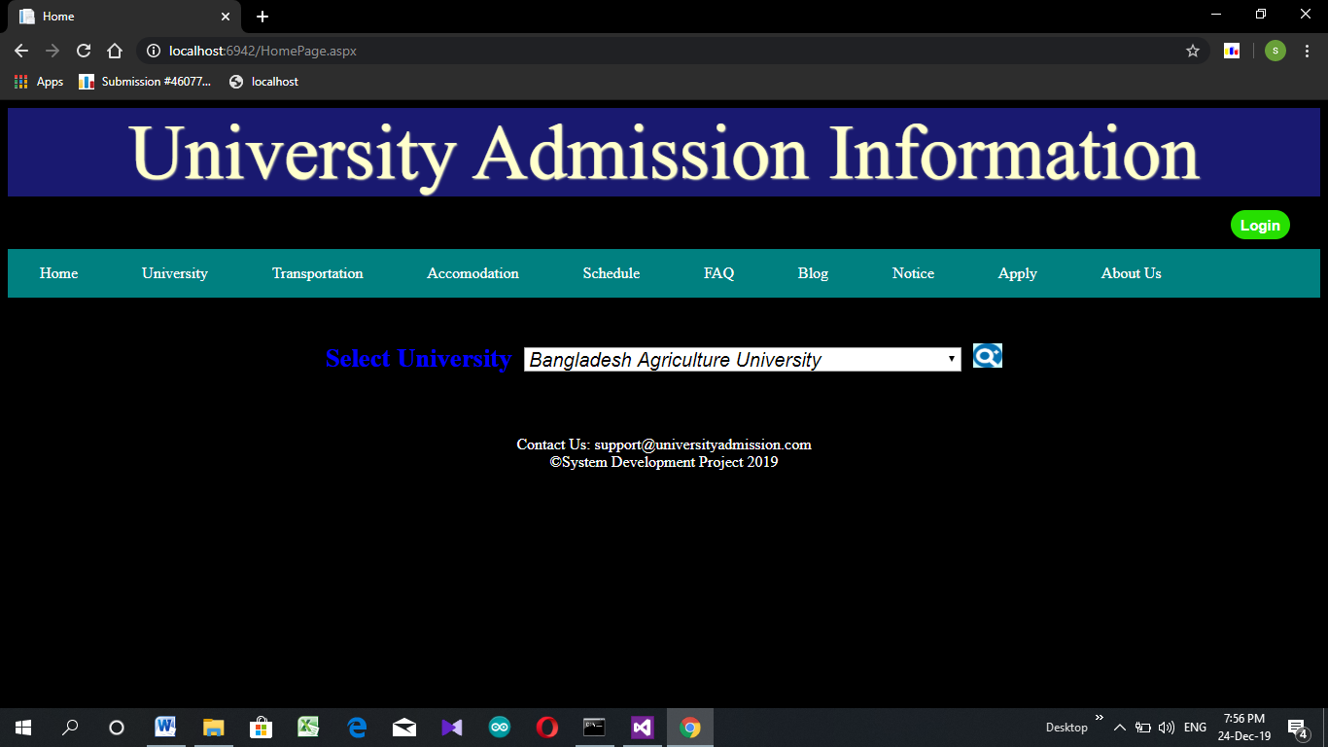

Fig: 3.2.1 Home page

Home page is consisting of a dropdown list, menu, and login button. Dropdown menu is filled up from database with name of university. If university is selected, then page will be forwarded to page of that university. If page is not available for selected university then there will be an error message through JavaScript alert. Menu provides linking between homepage and other page. Login button provides login features which will give facility to use FAQ, blog, apply section. If anyone is logged in, then there will two button. One containing the name of person who login connecting to profile page and a logout button.

**3.3 University**

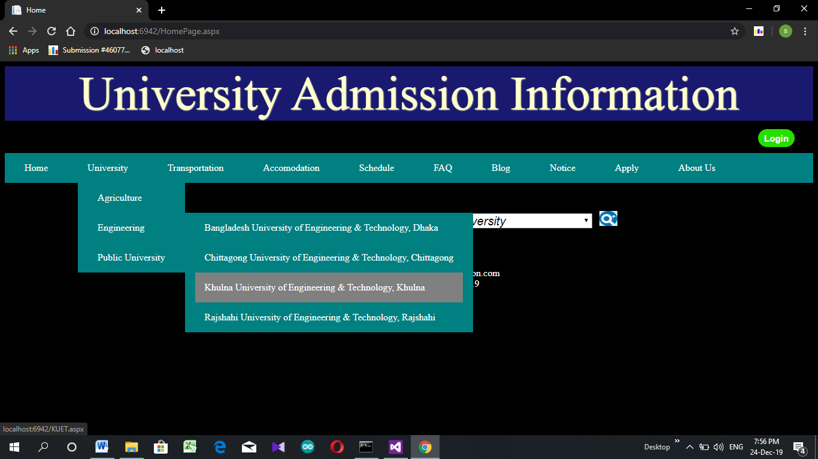

3.3.1 University

This is a dropdown list which show university name under different category. There are four universities under engineering category and 4 universities under agricultural. University names are linked to their corresponding pages. This is designed using html and css.

**3.4 Transportation**

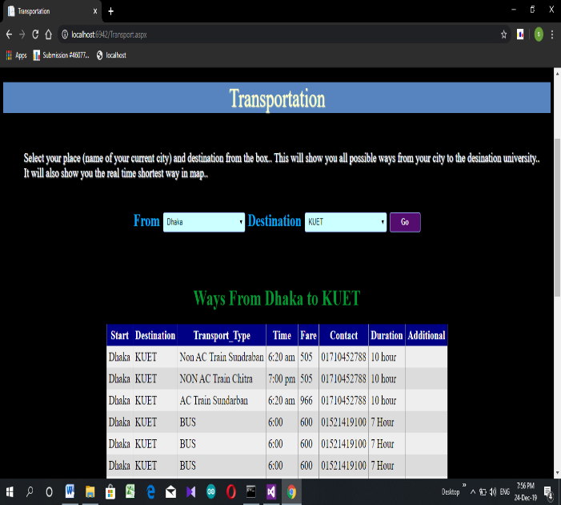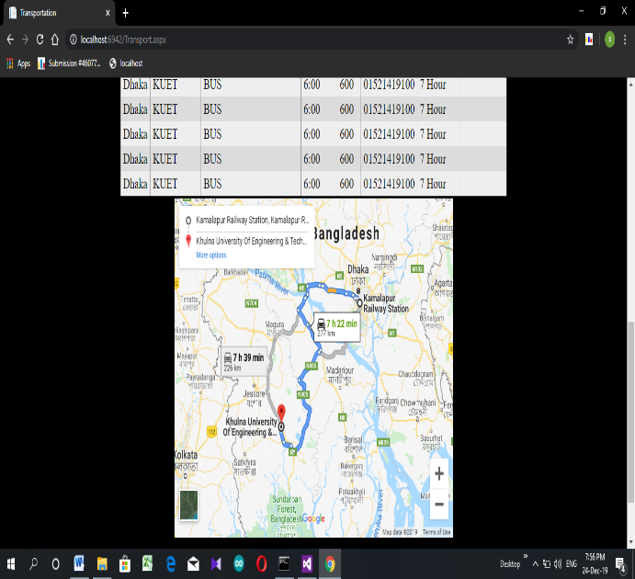

Fig: 3.4.1 Transport schedule Fig: 3.4.2 Transport road

In this page one can search for transportation details to a university. For this, one have select his district in from textbox and desired university in to textbox. Then after pressing “GO” button it will show transportation details with vehicle type, start time, duration, contact address. It will also provide google map for desired root.   
 All the information will be showed from database which is given by an admin. If some information not available, then it will be notified by alert. These all are controlled from server site by c#. Newly added information will be automatically updated. Login is not necessary to use this feature.

**3.5 Accommodation**

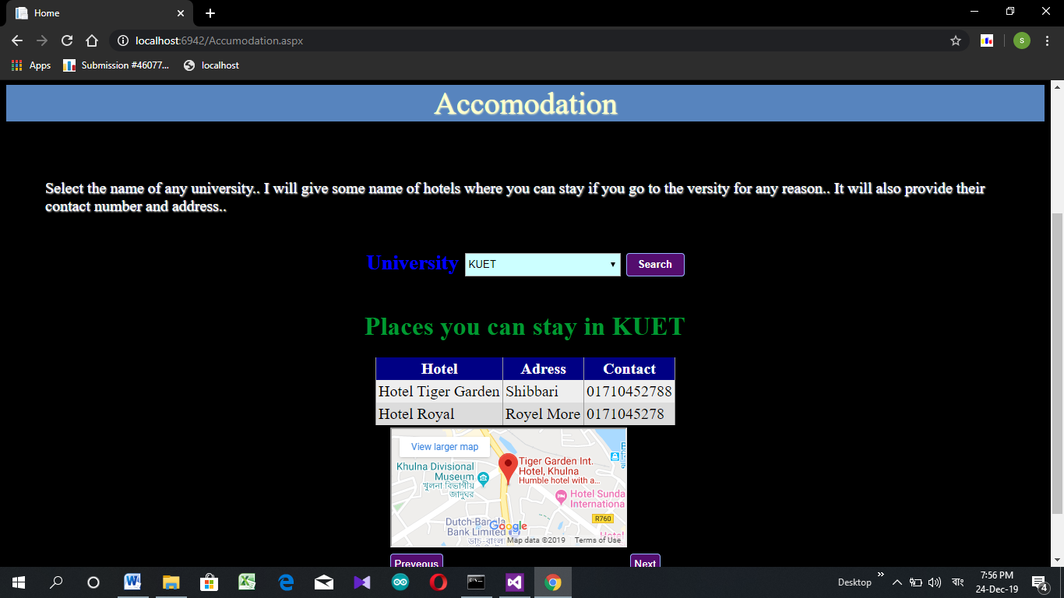

Fig: 3.5.1-accommodation

This is another important feature to find a place to stay near university during admission. The procedure is simple. One need select a university then click “Search” button. This will show Hotel name, Location and Contact address to user. Location of hotel will also be seen in google map.   
  
 All the information will be showed from database which is given by an admin. If some information not available, then it will be notified by alert. These all are controlled from server site by c#. Newly added information will be automatically updated. Login is not necessary to use this feature.

**3.6 Schedule**

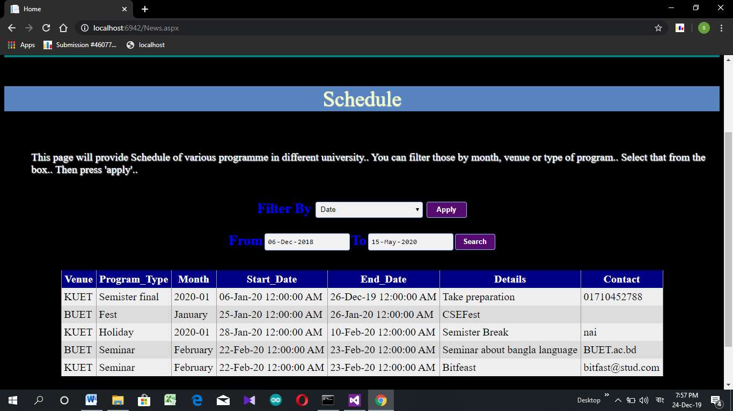

Fig: 3.6.1 Schedule

This page will show a student upcoming schedule such as examination date, result publication date, admission date at a single place. All the information is sorted in tabular form so that it can be understood easily. By default, it will show schedule for next one month.   
 Moreover, one can add filter to rearrange the data. It can be filtered using university name(venue), type and time region (from a date to another date).  
  
All the information will be showed from database which is given by an admin. If some information not available, then it will be notified by alert. These all are controlled from server site by c#. Newly added information will be automatically updated. Login is not necessary to use this feature.

**3.7 Frequently Asked Questions**

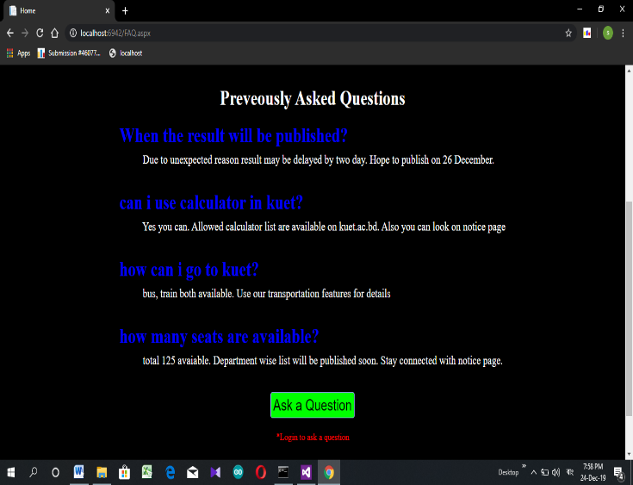 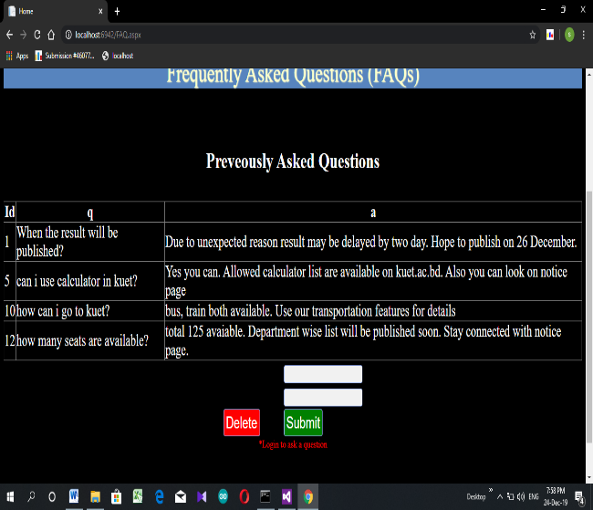

Fig: 3.7.1-FAQ for user Fig: 3.7.2-FAQ for Admin

Frequently asked questions is a feature where a student can ask a question and respected authority can answer the questions.

Here previously asked questions are visible to all. But to ask a question, students have to login to their student account, otherwise he will not get an option for asking questions(Fig).

When admin login using their id then they will get an option to answer the questions. Selecting a question number, admin can answer it or delete it(Fig ).   
  
 All the action is controlled by c# using database to store questions and answer.

**3.8 Blog**

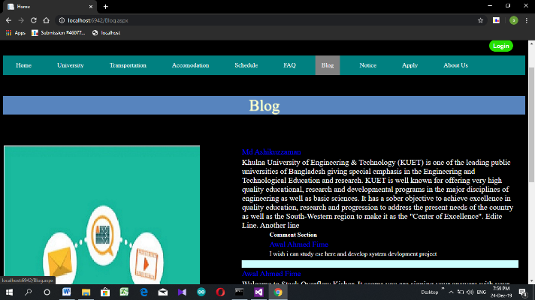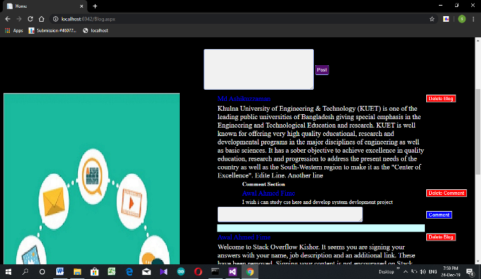

Fig 3.8.1- Blog with No Login Fig 3.8.2- Blog with Admin Login

Blog is a page which can be used as a platform for inter communication between students. To write a blog or comment on a blog one need to login first otherwise he will be only able to see post and comment in read only mode(Fig 3.8.1). Admin can also write a blog and comment on blog.  
  
 When a student login, he will get post, comment, delete, edit features. An admin can delete any post or comment (Fig- 3.8.2).

**3.9 Notice**

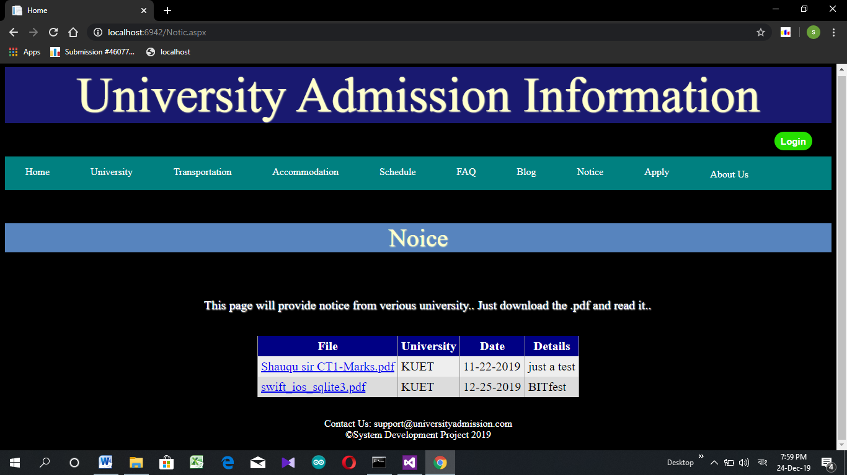

Fig: 3.9.1 – Notice Interface

Students can get their all-important notice here in a single place. Clicking On notice, it can be downloaded.

All the information will be showed from database which is given by an admin. These all are controlled from server site by c#. Newly added information will be automatically updated. Login is not necessary to use this feature.

**3.10 Apply**

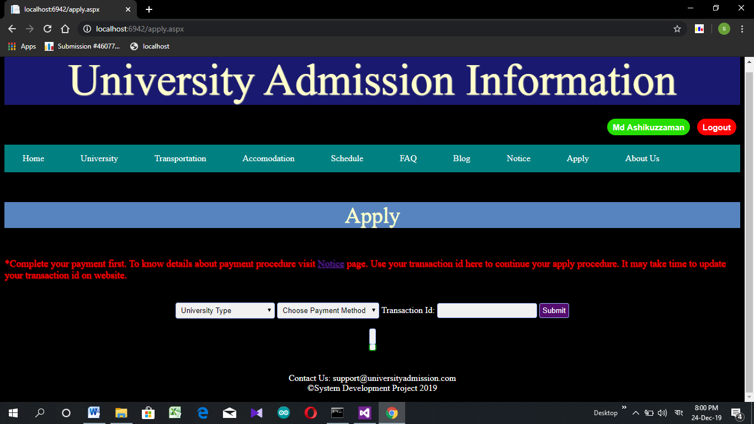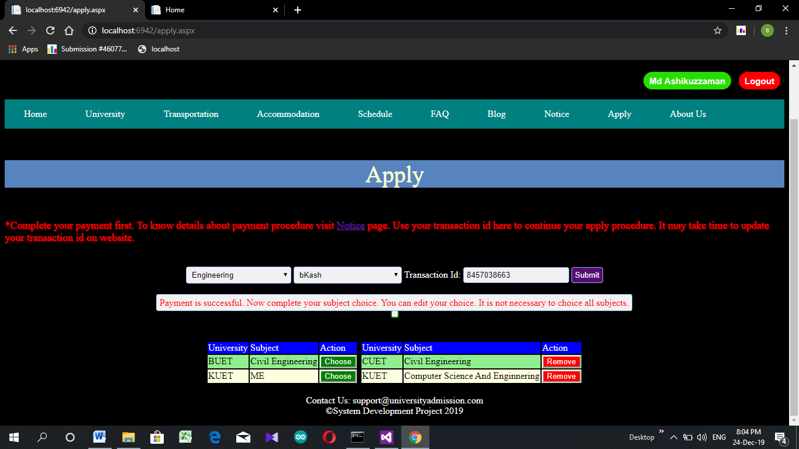

Fig: 3.10.1-Apply before payment Fig: 3.10.2-Apply after payment

Fig: 3.10.1 show the apply page. At first user has to select the type of university and the payment method form dropdown textbox. After paying the required fee he will get a transection id. He has to provide the id here. And click submit button.

If the payment is successful then this will take him to Fig: 3.10.2.

In Fig:3.10.2 he can choose his subject serial according to his preference. Subject choice serial can be changed any time. He does not have to press any button to conform his preference. It would automatically be saved in the database.

**3.11 University page**

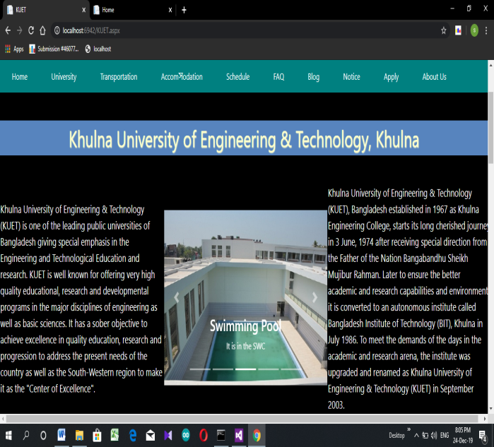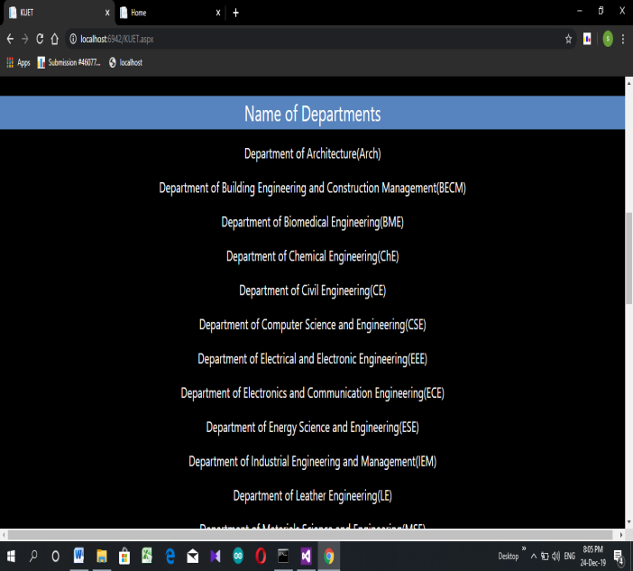

Fig: 3.11- University page top Fig: 3.11.2-University page middle

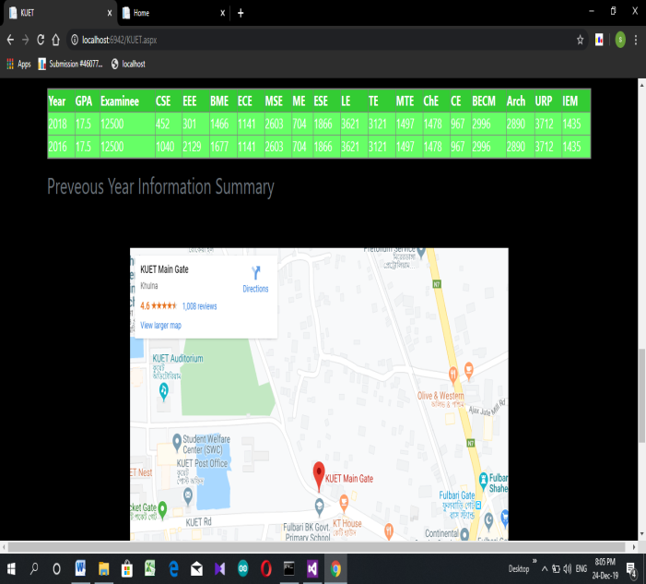

Fig: 3.11.3-University page lower

Fig: 3.11.1 Bootstrap is used to increase the beauty of the page. The pictures change after a few seconds.

This is the page for all university. This page would provide full name and the short form of the departments of all universities. All of the things in this website is in short form. To help the student sort form is provided.

Fig: 3.11.2 shows the starting and ending positions for previous years in every subject.

Fig: 3.11.3 shows the GOOGLE position of the university. It would be helpful for everyone to go to the university. It also provide

**3.12 Student profile**

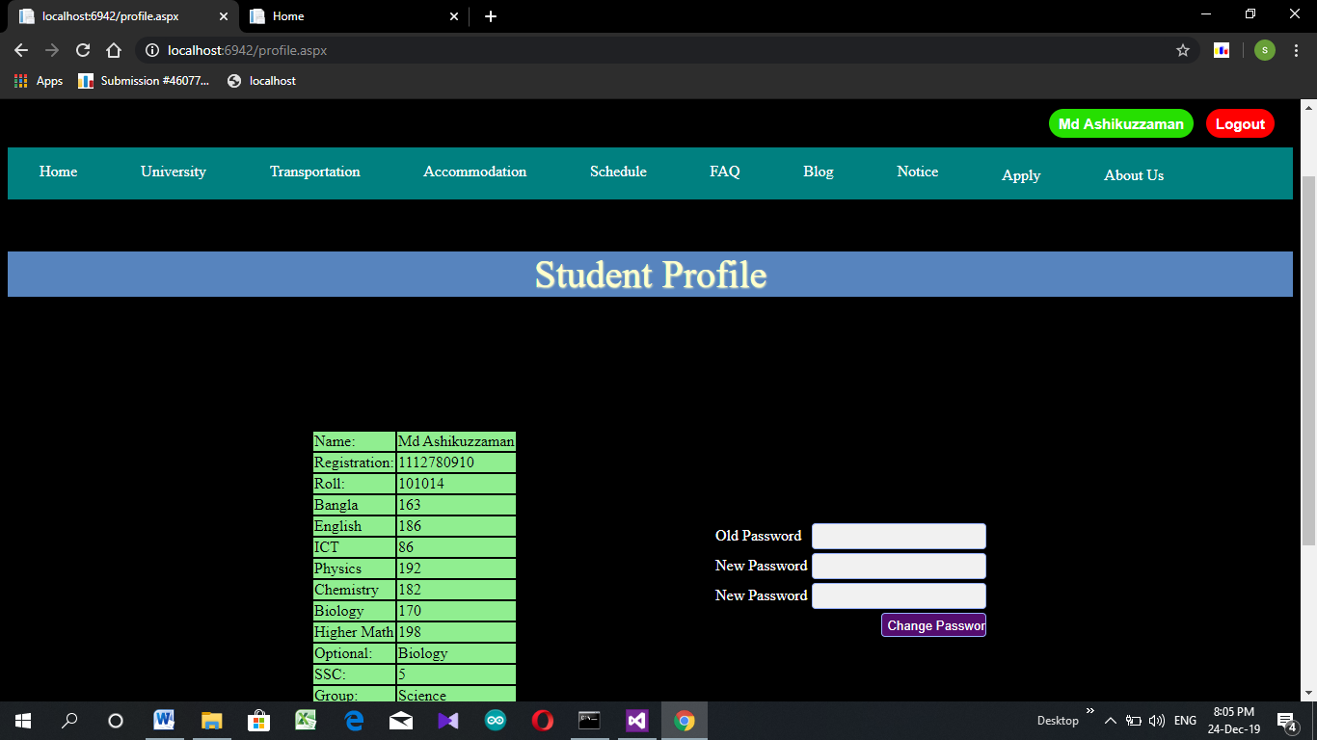

Fig: 3.12.1-Student Profile

Student profile is the main page for the user. User can see this after logging in to his profile.

This page provides all the information of the students. His name, registration number, roll number, marks in various subject, GPA in SSC and group.

This page would also provide interface to change the password. The user has to give his old password once and new password two time. Then the password would become the new one.

**3.13 Edit**

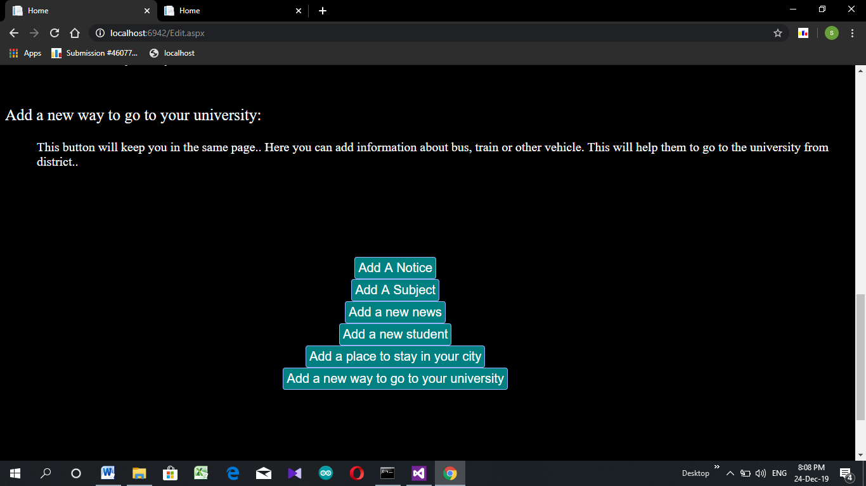

Fig: 3.13.1-Edit

This is the main page for editing most of the thing. It is also profile page for admin. Admin can add notice, add subject, news, add student, add place for accommodation of add a way to go to the university.

Admin can only see or come to the page. The editing would be done in the same page or related page linked with it. If the admin log out form here he will go to the home page of the website.

**3.14 Add a Notice**

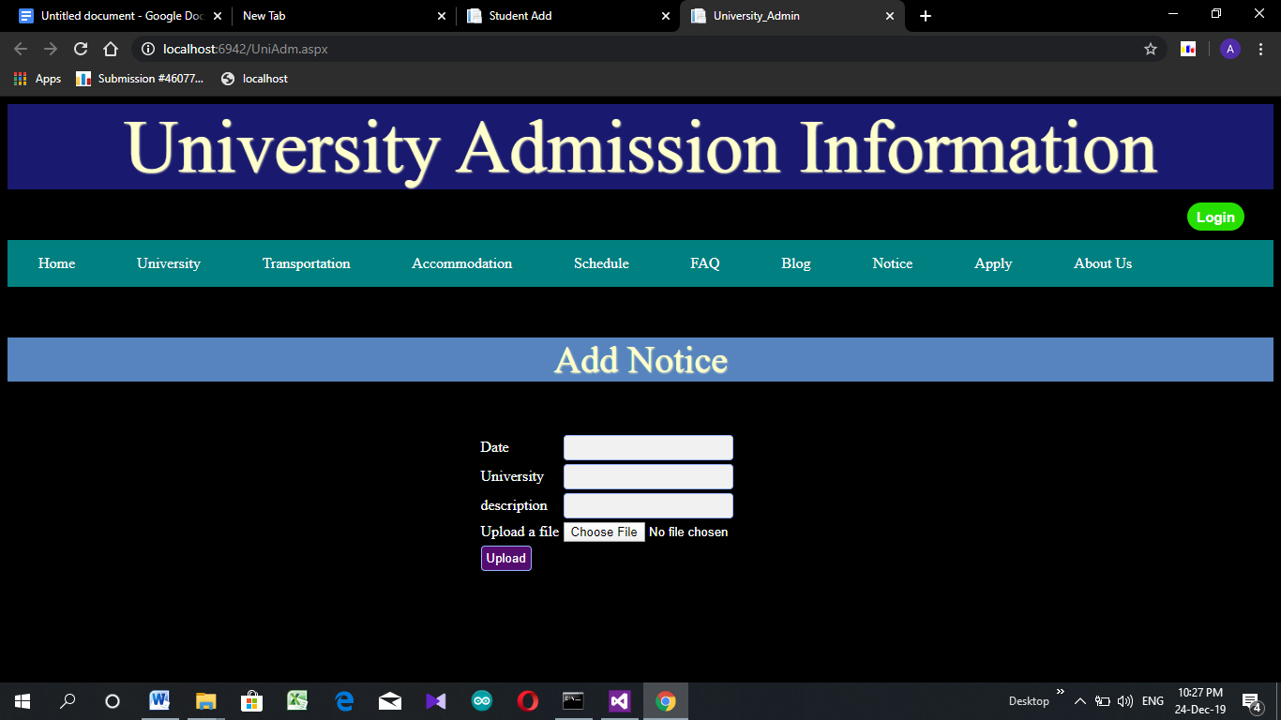

Fig: 3.14.1-Add Notice

This page is for adding a notice. Only admin can add this after logging in by his registration number and password. He can add the date for the program, name of the university, description (if available). Admin can add a notice it would be in .pdf format.

This pdf has a maximum size. Pdf must note be over 4MB

**3.15 Add news**

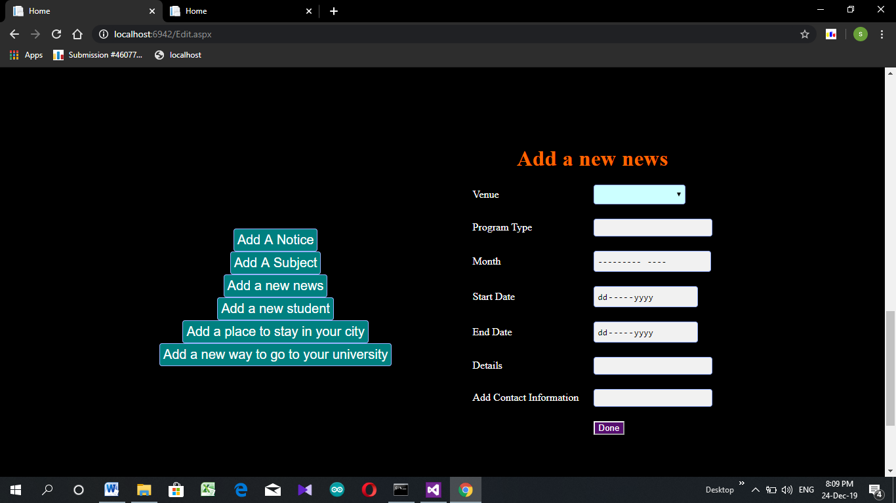

Fig: 3.15.1-Add News

This is the schedule of all programs that would happen in the university. Event could be any type.

To add an event admin has to select the name of the university from dropdown textbox. He also have to add the type of the program, in which month it would happen, start and end date for event. He also can add any details (if available) and contact number.

**3.16 Add a Student**

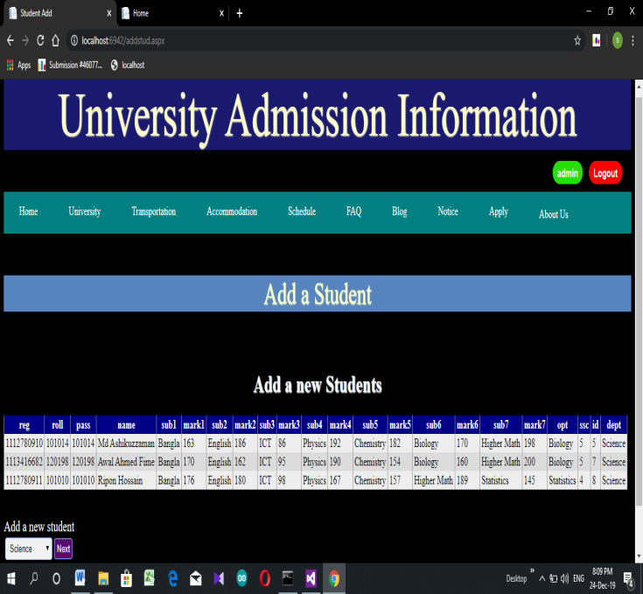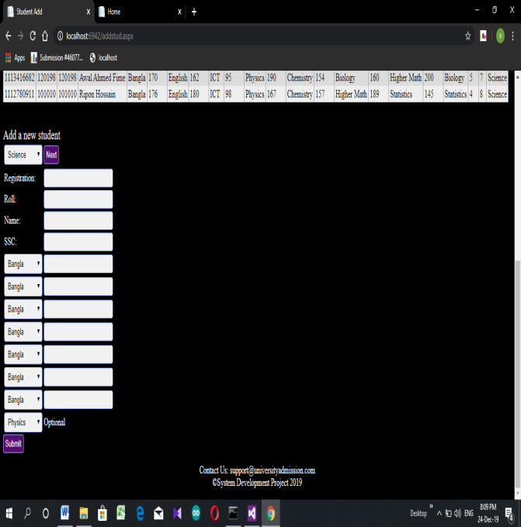

Fig: 3.16.1 Add Student

This page is for adding a student in database. Our base idea is getting information from the database of educational boards. As it is not available for us right now. So we have created this interface.

To add a student admin has to add his group. As well as roll number, registration number, Name and GPA in SSC. Unique student would be identified by his registration number. If the student already exist then the website would notify in JS. If the student is not available then admin has to add his mark in all 7 subjects and the name of his optional subject. And press submit.

**3.17 Place to stay**

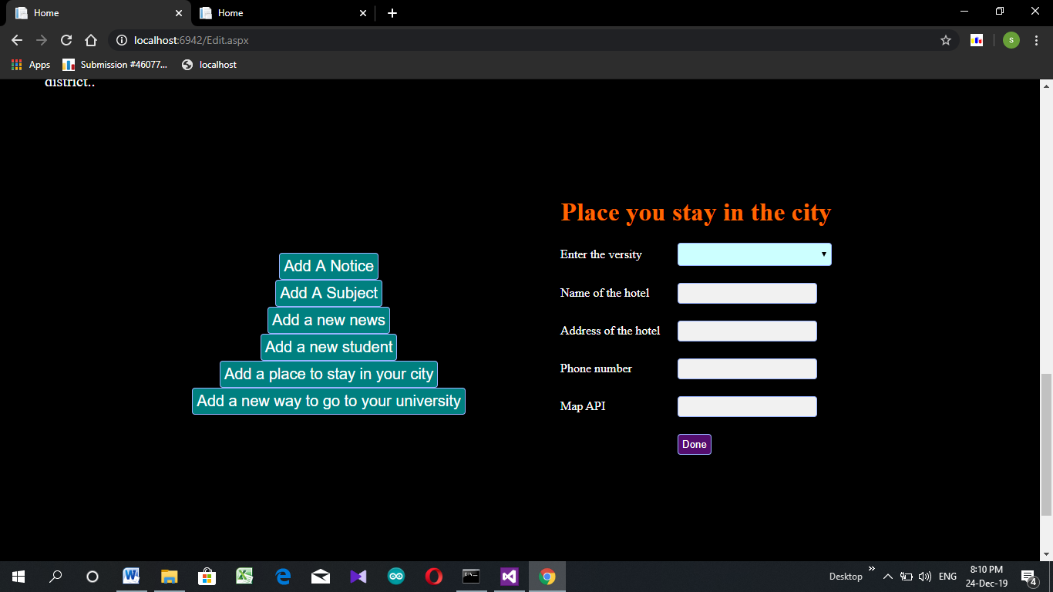

Fig: 3.17.1-Place to stay

Admin can add a place where anyone can stay when he goes to the university. It is generally a hotel, motel or this kind of thing. To enter this admin has to enter the name of the university from dropdown menu. Admin also have to give the name of the hotel, address and phone number.

Admin also have to provide the location from GOOGLE map. It is the address provided by the GOOGLE map without the <iframe>.

**3.18 Add a way to go**

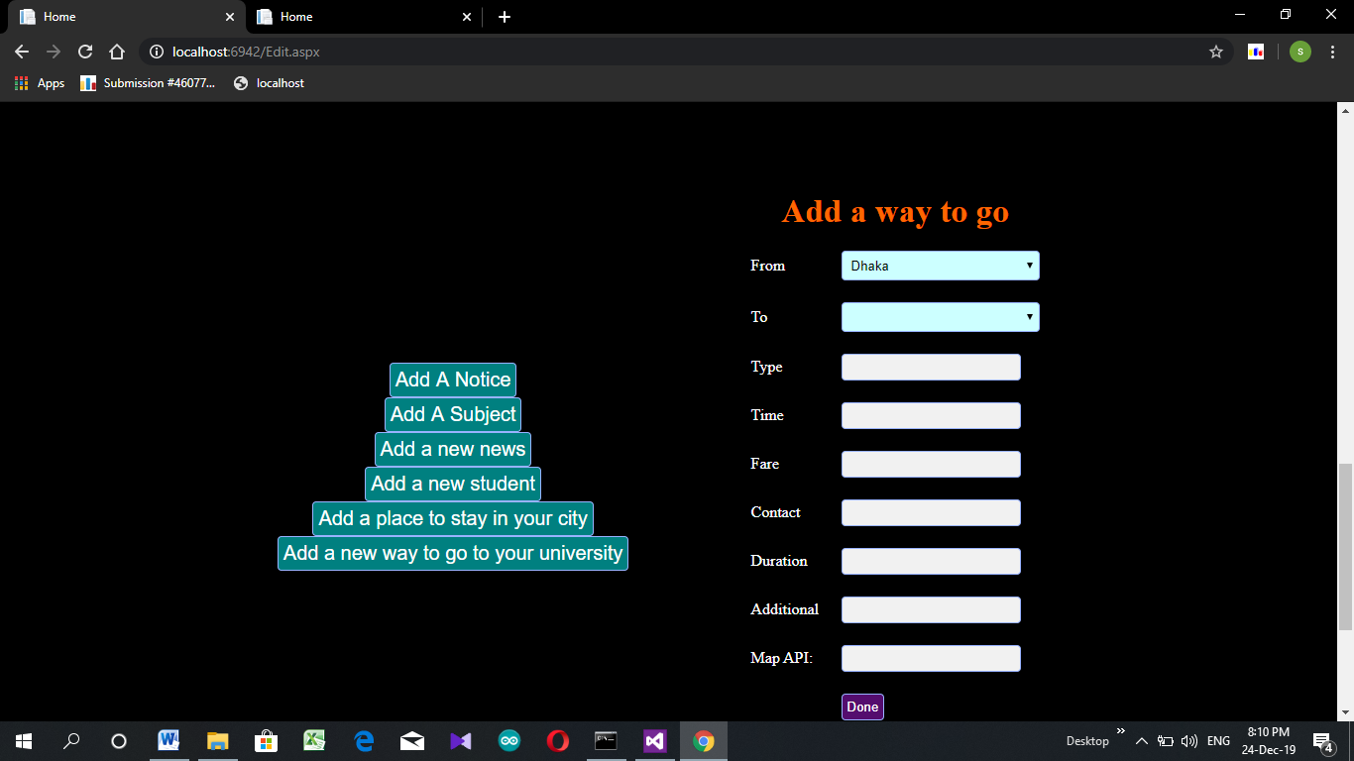

Fig: 3.18.1-Way to go

Admin would be able to add a way from a district to a university. He must select the district and destination university from the dropdown box. He can add the type of the transport, time it takes to go from source to destination, current fare, Contact number of counter, time when the vehicle starts, any additional information(if available), Map API.

Map API is the API address generated by the google map after searching road. It just need the address without <iframe>.

**3.19 Add a Subject**

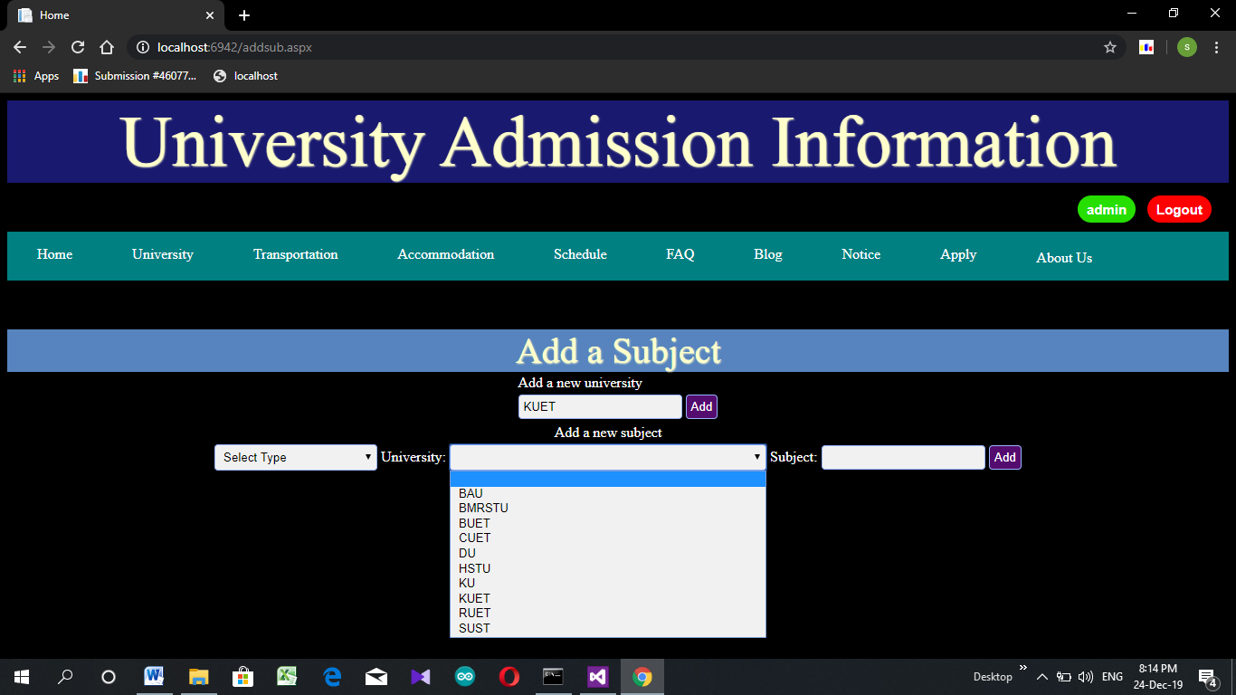

Fig: 3.19.1 Add Subject

If a new subject is added in a university, this could be added to the website from this page. Only Admin can do this. The university must be added before the subject is added. If the university is existed in the database then there is no need to add it again.

If someone tries to add a university which is already existed in the database, then it would show ‘Varsity already listed’ in JS. Similarly if someone tries to add a subject already existed in the database. It would also show a message.

Type must be selected to add a subject.

**3.20 Login**

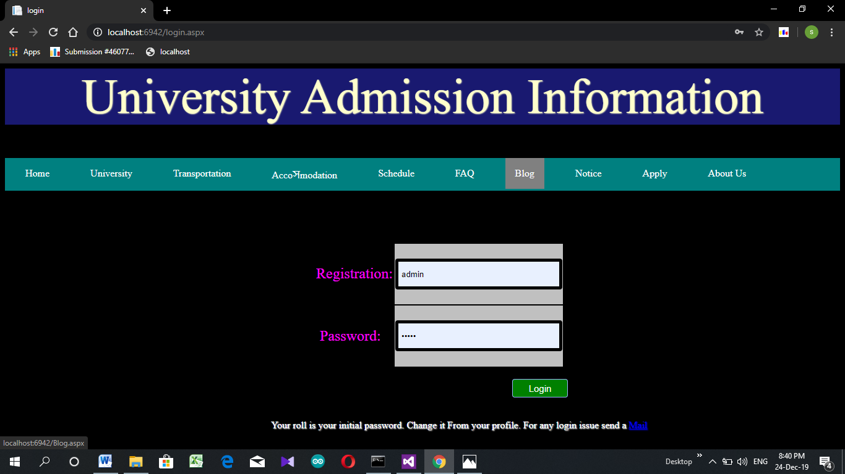

Fig: 3.20.1 LogIn

This page is for login. Admin and user can log in from the same page. This page will take registration number and password. It would first search in admin database then user database. If there is no such registration the page would show “Registration not found”. If registration is available but password is not matching then this would show “Invalid Password”

Roll number for any corresponding registration is initial password for all. It can be changed later. If someone forgets password then he should press on ‘Mail’. It would help him to recover his password.

**Chapter 4  
Result Analysis**

**4.1 Introduction** This web based system can be used for solving many problem and giving many privileges to students in a better way. But it still has some limitation related to database access and exception handling.

**4.2 Large Database**

To provide a complete student friendly environment a large database in necessary. Inserting so many information to database is a time consuming process.

**4.3 Temporary Table Construction** In this website, student login is designed on based on HSC roll and registration no to link it to apply section. But access to education board website was not available. So login was managed by creating a temporary database table.

**4.4 Incomplete Payment System** Due to unavailability of related resource, payment system was not completed.

**4.5 Limited File Size**

The project is developed in debug mode. Debug mode supports 4MB file transfer by default. Sometimes, excess data transfer causes exception.

**4.6 Organized Information**

Transport, accommodation, schedules are provided in more organized way.

**4.7 Authentic Information Source** Students can get authentic and reliable information.

**Chapter 5  
Conclusion**

This web based system can be really helpful for admission students. If enough supports, access, resource are provided by respected authority then this can be upgraded to higher level solving the limitations.

**Chapter 6**

**Reference**

1. <https://bdnews24.com/bangladesh/2013/11/26/zafar-iqbal-yasmeen-resign>
2. <https://admissioninfos.com/agricultural-university-admission-circular-2019-20-pdf-download/>
3. <https://www.facebook.com/groups/kuetadmissioninfo/>
4. <https://www.facebook.com/groups/BuetAdmissionTest2016/>
5. <http://admission.kuet.ac.bd/adm/>
6. <http://www.ruet.ac.bd/admission/>
7. <https://www.cuet.ac.bd/admissiontestnotice17-18.php>
8. <https://www.buet.ac.bd/web/Home/Admission>
9. <https://www.facebook.com/groups/kuetadmissioninfo/members/>
10. <https://stackoverflow.com/questions/18914357/how-to-add-controls-dynamically-when-click-button-in-asp-net/18914526>
11. <https://stackoverflow.com/questions/3270774/how-to-integrate-google-maps-in-a-web-application>